**Inputs**

|  |  |
| --- | --- |
| Energy Converter Specifications | |
| Engine | Stellantis |
| Engine weight | 229 |
| Engine power | 193 |
| Engine RPM range |  |
| Engine peak torque |  |
| Generator |  |
| Generator weight |  |
| Generator RPM range |  |
| Generator peak torque |  |
| Generator quantity |  |
| Generator Efficiency @peak power of engine |  |
| Motor Inverter Specifications | |
| Motor |  |
| Motor weight |  |
| Motor RPM range |  |
| Motor peak torque |  |
| Motor quantity |  |
| Motor peak power |  |
| Motor peak power duration |  |
| Motor continuous power |  |
| Energy Storage Specifications | |
| Max battery capacity |  |
| Battery weight |  |
| Battery C-Rate max |  |
| Battery max charging power |  |
| Battery duration for max charging |  |
| Battery continuous charging |  |
| Battery max discharging power |  |
| Battery duration for max charging |  |
| Battery continuous charging |  |

**Outputs**

|  |  |
| --- | --- |
| Vehicle Specifications | |
| Vehicle weight | 2450 |
| Final drive ratio | 5.835 |
| Lap time | 29529.6 |
| Fuel Consumption (mpg) |  |

**Plots: Energy Converter**

**Plots: Motor**

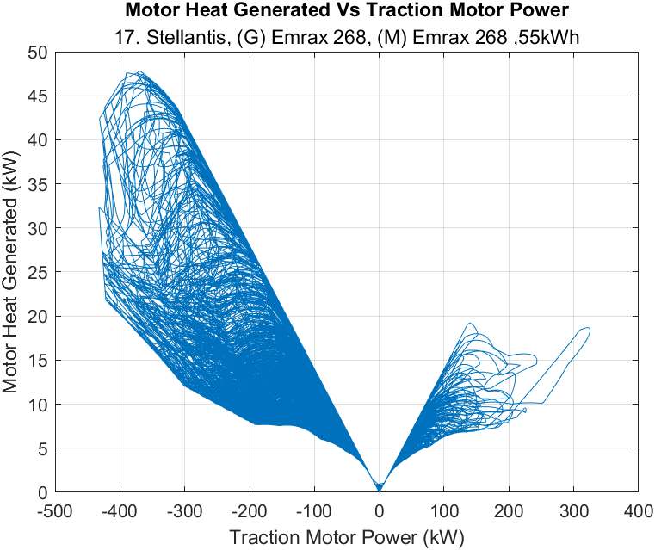

**Plots: Energy Storage**

